THE WONDERFUL WIZARD OF OZ
Below are two passages for L. Frank Baum’s classic story The wonderful Wizard of Oz. The first passage is about Dorothy’s home in Kansas. The second refers to the road outside the Emerald City in. Read both passages and answer the questions.
PASSAGE A
When Dorothy stood in the doorway arid TY looked around, she could see nothing but the great gray prairie on every side. Not a tree nor a house broke the broad sweep of flat country that reached to the edge of the sky in all directions. The sun had baked the plowed land into a gray mass, with little cracks running through it. Even the grass was not green, for the sun had burned the tops of the long blades until they were the same gray color to be seen everywhere. Once the house had been painted, but the sun blistered the paint and the rains washed it away, arid now the house was as dull arid gray as everything else.

1. What is the most common color of the area around Dorothy’s home?
2. Does this sound like a pleasant place?

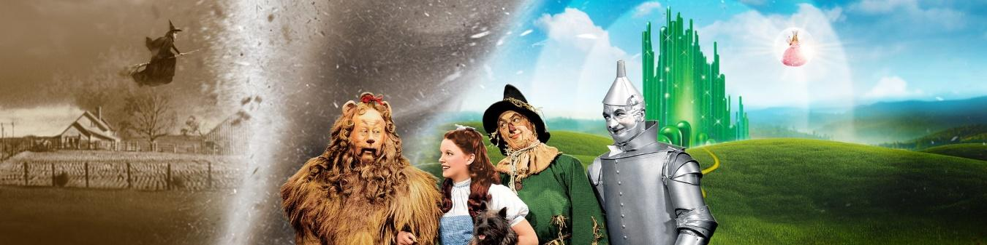

PASSAGE B
"The road was smooth and well paved, now, and the country about was beautiful, so that the travelers rejoiced in leaving the forest far behind, and with it the many dangers they had met in its gloomy shades. Once more they could see fences built beside the road; but these were painted green and when they came to a small house, in which a farmer evidently lived, that also was painted green.
They passed by several of these houses during the afternoon, and sometimes people came to the doors looked at them as if they would like to ask questions; but no one came near them nor spoke to them because of the great Lion, of which they were very much afraid. The people were all dressed in clothing of a lovely emerald-green color arid wore peaked hats like those of the Munchkins.
3. What is the most common color of the surroundings in this passage?
4. Does this sound like a pleasant place?
5. What do you think the author is trying to say about the differences in these two places?

