Conjunctions Chart

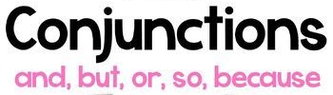

Instructions: Complete the following chart with information from the video you watched.
Instructions: Complete the following chart with information from the video you watched.https://www.youtube.com/watch?v=DJW8IXaW7M4
Conjunction | Use | Example
AND
BUT
SO
OR

