**PRONOUNS**

|  |  |  |  |
| --- | --- | --- | --- |
| **SUBJECT**  **PRONOUNS** | **OBJECT**  **PRONOUNS** | **POSSESSIVE**  **ADJECTIVES** | **POSSESSIVE**  **PRONOUNS** |
| **I** | **ME** | **MY P** | **MINE** |
| **HE V** | **HIM** | **HIS O** | **HIS** |
| **SHE E** | **HER** | **HER SS** | **HERS** |
| **IT R** | **IT** | **ITS E** | **\*** |
| **WE B** | **US** | **OUR SS** | **OURS** |
| **YOU** | **YOU** | **YOUR ION** | **YOURS** |
| **THEY** | **THEM** | **THEIR** | **THEIRS** |

**Ej. He loves me (not I)**

**They play with him (not he)**

**This is my car.**

**This car is** mine.

**Whose book is this? It´s hers.**

**It´s her book.**

**Possessive case ´s**

**My mother´s sister Veronica and John´s house**

**Carlos´s brother Mr. John Smith´s apartment**

**James´s pen**

**The boys´ball My parents´house**

**The boy´s ball**

**The children´s ball The child´s toy The men´s bathroom**

**The women´s bathroom The woman´s bathroom The man´s bathroom**

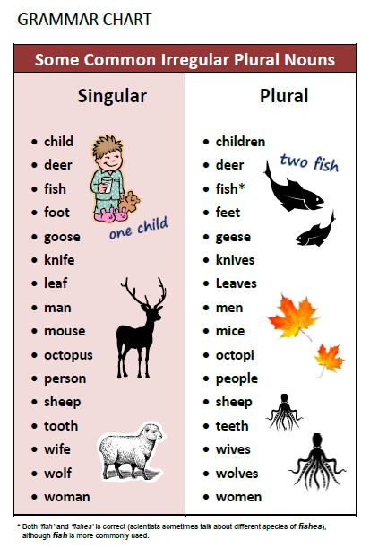

**Answer key to Marvel´s exercise**

**Iron man is determined, adventurous, arrogant.**

**Thanos is self-centered, bad tempered and mean.**

**Captain America is caring, generous, tactful and understanding.**

**Loki is jealous, sneaky, unreliable.**

**Black Panther is fair and honest. He is also helpful and loyal.**

**Hulk is very amusing, aggressive, stubborn.**