Activity 1: Warm up
First day at Hogwarts. Students have forgotten one magic item at the Diagon Alley and have to remember it before the Hogwarts Express leaves at 9:00. Every time they say a wrong letter, the clock will move 5 minutes forward.
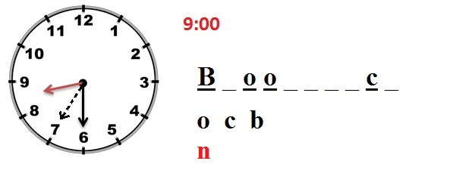
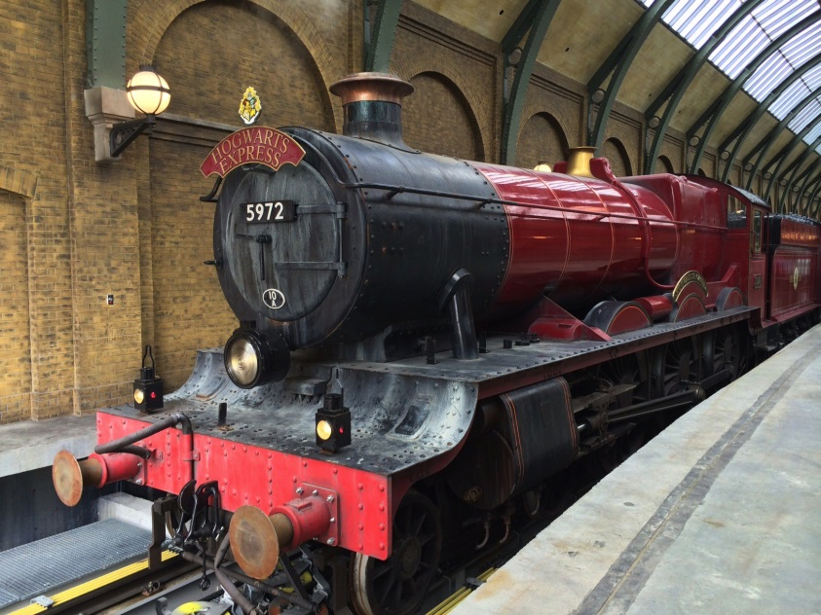

Activity 2: Presentation
The teacher will explain the sorting ceremony to the students, and then they will introduce the features that characterize each House. By looking at the sentences, students will guess the meaning of those adjectives (pre-task)
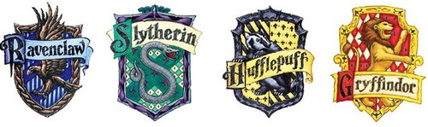
Analytical  Intelligent  Curious  Creative  Introspective | Ambitious  Ruthless  Proud  Self-reliant  Cunning | Hard-working  Fair  Loyal  Patient  Friendly | Honest  Practical  Brave  Playful  Stubborn

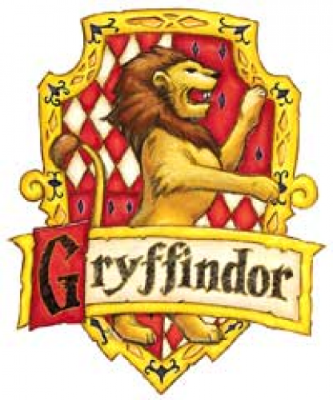
Gryffindors are very stubborn, when they think something; it is very difficult to change their mind. They are very brave, they are always ready to face any danger. They are also honest, they always go ahead with the truth.

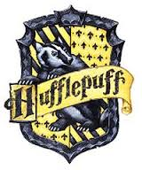
Hufflepuffs are hard-working since they put a lot of effort in what they do, and they are the best friends you can have because they are very loyal. We it comes to competition, they are very fair, since they don’t try to break the rules and have no problems to acknowledge that you have won.

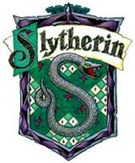
Slytherins are so competitive that they are ruthless with their opponents. They are very proud of their house, since they believe that it produces the most powerful magicians. Each one of them is very self-reliant, because they think that they have been chosen for their extraordinary skills. They are also very cunning, they always find a way to achieve their goals.

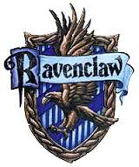
Ravenclaws are extremely intelligent, they appreciate wisdom above all. They are so curious that they can spend hours at the library looking for a lot of things they are interested in. They are also good at producing art, since they are very creative.

Activity 3: Practice
- Complete the following crossword with the clues below.

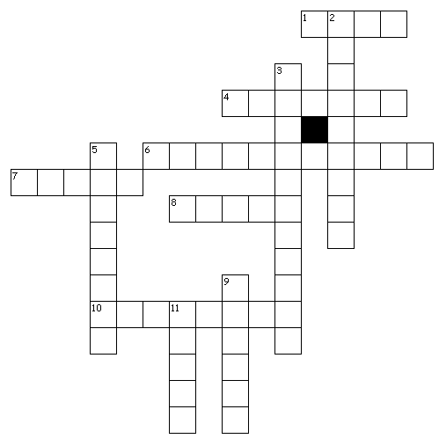
Across
1. just, equitable
4. clever at planning something so that they get what they want
6. trusting to one's own powers
7. having too high an opinion of oneself
8. demonstrating constant support for someone
10. refusing to change one's opinion
Down
2. greatly desirous of honor, distinction...
3. of high cognitive capacity
5. cruel, without compassion
9. scrupulous with regard to telling the truth
11. strong in the face of fear, courageous
- Fill in the blanks with the words from the crossword above, each word may appear several times.

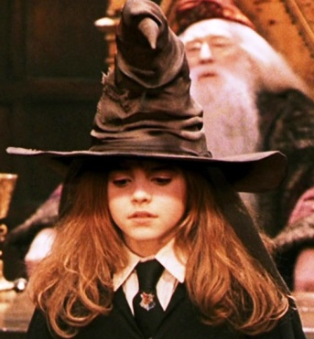
The Sorting Ceremony began. Hermione Granger was called first. McGonagall put the sorting hat on her head and it started to think. The hat found that Hermione was extremely _________, she would be a top student, and it thought about putting her into Ravenclaw. However, it also found that she was very _______ and ______, as she was determined to not to cheat and face any consequence derived from that. Finally it decided to sort her into Gryffindor.
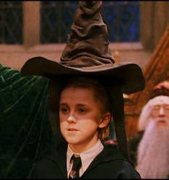
Draco Malfoy was called next. His parents were very famous for being _______ with those they didn’t like and also they were very _______ of their position as a wealthy family, in fact, they were supporters of You-Know-Who in the past. Draco was also very ________ about his abilities. The sorting hat didn’t hesitate at all. Before even touching his head, the sorting hat screamed: “Slytherin!”
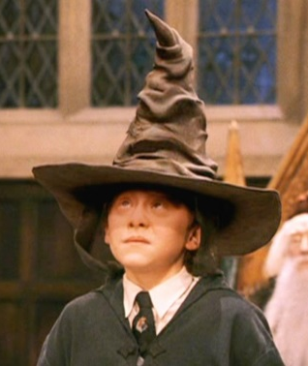
Ron Weasley was next. Many thought he would be sorted into Hufflepuff, as he wasn’t too ______ to be a Gryffindor, nor too ________ to be a Ravenclaw nor too ________ to be a Slytherin, but he was _____ and _____ with his friends, as he always was there to help them. However, he was _________ as it was very difficult to change his mind, and he really wanted to be in Gryffindor with his brothers. Finally, the sorting hat decided to sort him into Gryffindor.

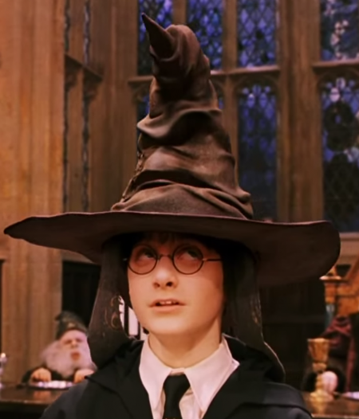
Harry Potter was the last one. The sorting hat found it very difficult to decide. On the one hand, Harry was ________, as he wanted to prove himself beyond limits, and also he was __________ enough to achieve his goals. On the other hand, he was very _______, as he was ready to face any challenge. Also _______, as he was very consequent to what he believed to be right. Harry didn’t want to be in Slytherin and so the sorting hat finally said: “Well, if you’re sure, better be… GRYFFINDOR!”

Amplification
Which Hogwarts’ House do you think you would be sorted into? Explain why.

Activity 4: Production
Four students will be given a hat. Each one of them will have to find a student of a given house. For instance:
Hat 1 has to find 4 Gryffindors.
Hat 2 has to find 4 Slytherins.
Hat 3 has to find 4 Ravenclaws.
Hat 4 has to find 4 Hufflepuffs.
The rest of the students will be given three characteristics and the hats have to ask them to describe themselves. Then, they will decide if the description can match with the House they are looking for. The first House to complete the required number of students wins.

